**Automation Design Document**

Contents

URL 2

Configuration 2

Test Data 3

Test Cases 4

Automation Execution Workflow 5

Framework Details (Page Object Model) 6

Sample Report 7

# URL

URL: <https://accounts.google.com/>

# Configuration

Following details need to be updated before running the Test cases

1. URL
2. Browser (only chrome is implemented for now)
3. Screenshot Path folder
4. Reports Path

Folder will automatically get created on the mentioned drive by the application.

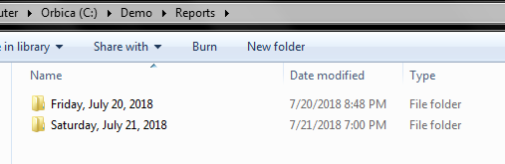

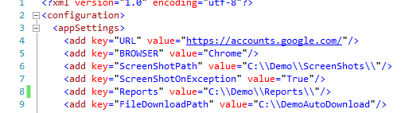

# Test Data

We can change test data in EMailSearchTestCase.xlsx file as per our requirement.

Right now I have used my Login ID and password but, you can try your credentials as well. It should be separated by semicolon.

For searching Email we need to provide subject.

Test case will get fail in case of wrong data.

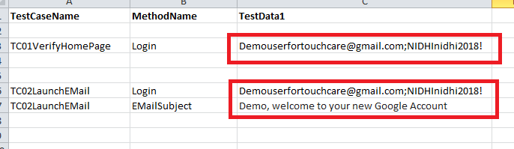

# Test Cases

Implemented 2 test case

* Verify Home page loaded successfully after login to the Gmail execution. (Positive scenario)

It will login to the application and will verify that home page is loaded successfully.

* Verify that the user is able to Login to Gmail and launching specific searched Email. (Positive scenario)

It will login to the application and will verify that home page is loaded successfully. And then it will search given Mail (subject) and launch that mail.

# Automation Execution Workflow

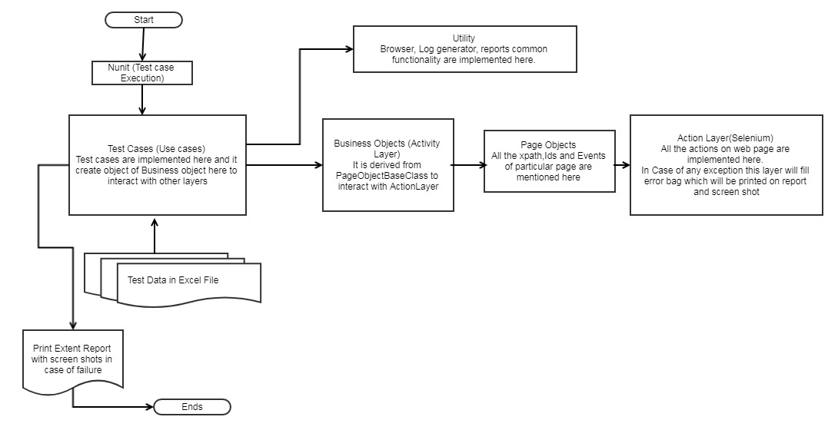

# Framework Details (Page Object Model)

1. **Page Objects**: Details of a page like XPath and events on web pages like button click, alerts, file upload etc.
2. **Business logic**: All the logic of Page implemented here and this class is derived from page object Base classes.
3. **Action classes**: All the actions of a like button click, Text box, etc.
4. **Test Cases**: Steps to Test workflows.
5. **Utility Classes**: Browser, Excel Reader, reports, common functionality are implemented here.
6. **Test data:** Excel sheets which is Different for each Test Class.
7. **Enum and structures:** Structure and enum used in test cases and business to fill some structures.
8. **Config:** Path of screenshots, which browser to use**,** where to generate logs Reports etc.

# Sample Report

Left side of the below screen shows test case name and right hand side shows steps followed in execution

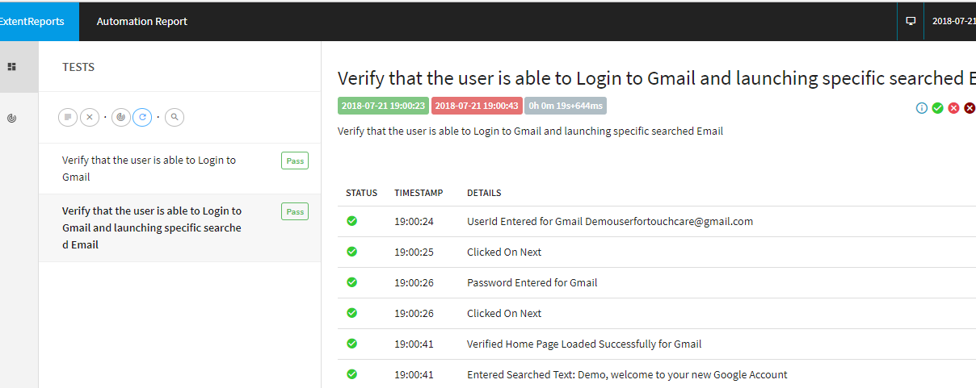

Below screen shows number of test cases executed in test suit and graphical presentation

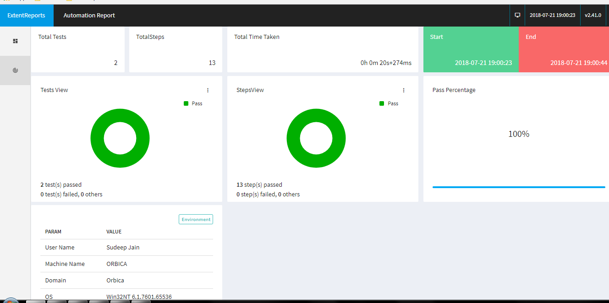

In case of error it will take screen shot , as shown in figure below:

